**Graphical Representation**

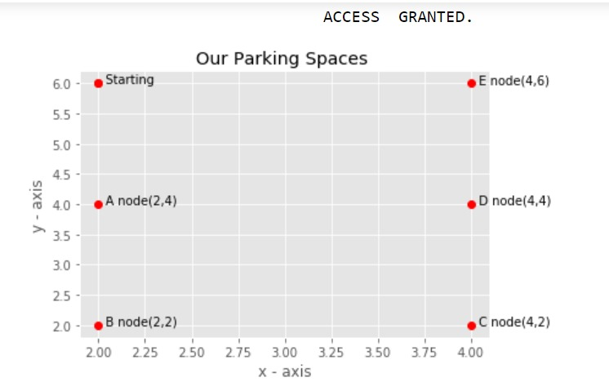

So in the above graph we have 6 nodes which we consider as 6 parking spaces. Further we used BFS(Breadth for Search) in order to visit each and every node.

Breadth for Search:

It is an algorithm for traversing or searching tree or graph data structures. Breadth first search is a graph traversal algorithm that starts traversing the graph from root node and explores all the neighboring nodes. Then, it selects the nearest node and explore all the unexplored nodes. The algorithm follows the same process for each of the nearest node until it finds the goal.

It starts at the tree root (or some arbitrary node of a graph, sometimes referred to as a search key), and explores all of the neighbor nodes at the present depth prior to moving on to the nodes at the next depth level.

Mechanism:

Here we are considering a list called available list which consists of all the nodes that are visited once. So after presenting the available list of nodes we are going to ask user that which node he or she is going to prefer to park his/her vehicle. Thereafter, the node which chosen by the user is removed from the available list and the available new list will be modified for the next user.

So finally in this way the user gets the available list to choose from and hence makes his/her parking convenient and easy, helps free the traffic optimize parking space usage and predict the plot to park precisely saves our time and money more over reduces stress.